

FOODVERSE – INTELLIGENT FOOD DISCOVERY AND SMART ORDERING SYSTEM
A CAPSTONE PROJECT REPORT

A Capstone Project Report submitted in partial fulfilment of the requirements
for the Course of
CSA43 – INTERNET PROGRAMMING
to the award of the degree of
BACHELOR OF ENGINEERING / BACHELOR OF TECHNOLOGY
IN
COMPUTER SCIENCE AND ENGINEERING (BRANCH)

Submitted by
- Swathish Reddy (192371075)
L Venkata Jeswanth Reddy (192372375)
Naga Hruday Deepak()
Under the Supervision of
Dr Marie Claude
SIMATS ENGINEERING
Saveetha Institute of Medical and Technical Sciences
Chennai-602105

SEPTEMBER 2026

SIMATS ENGINEERING
Saveetha Institute of Medical and Technical Sciences
Chennai-602105
BONAFIDE CERTIFICATE
This is to certify that the Capstone Project entitled “FoodVerse – Intelligent Food Discovery and Smart Ordering System” has been carried out by Swathish Reddy (192371075) , L Venkata Jeswanth Reddy (192372375) , SWATHISH REDDYR(192371075) under the supervision of Dr Marie Claude and is submitted in partial fulfilment of the requirements for the current semester of the B.Tech program at Saveetha Institute of Medical and Technical Sciences, Chennai.

COURSE COORDINATOR | COURSE FACULTY
Dr Marie Claude  Professor  Neural Networks  Branch: CSE | Dr Marie Claude  Professor  Neural Networks  Branch: CSE

SIMATS ENGINEERING
Saveetha Institute of Medical and Technical Sciences
Chennai-602105
DECLARATION
I, L Venkata Jeswanth Reddy of the CSE- Biosciences, SIMATS Engineering, Saveetha Institute of Medical and Technical Sciences, Chennai, hereby declare that the Capstone Project Work entitled “FoodVerse – Intelligent Food Discovery and Smart Ordering System” is the result of our own bonafide efforts. To the best of our knowledge, the work presented herein is original, accurate, and has been carried out in accordance with the principles of engineering ethics and academic integrity. All sources, references, data, and other materials used in the project have been appropriately acknowledged. We further declare that the data, results, analysis, and findings presented in this report have not been fabricated, falsified, or manipulated. Any external tools, software, datasets, computational resources, or AI-assisted tools used during the project have been appropriately disclosed. We confirm that all applicable ethical, academic, institutional, and professional requirements have been duly followed throughout the planning, execution, analysis, and documentation of the project.

Place: Chennai
Date: __ / __ / 2026

Signature of the Students with Name

SIMATS ENGINEERING
Individual Contribution Statement
(Mandatory for all team projects)
Student Name / Register No. | Specific Responsibilities | Design & Development Contribution | Testing & Analysis Contribution | Report Contribution
R SWATISH REDDY  (192372164) | UI design, JSP pages, search and recommendation interface | Frontend, JSP, JavaScript, integration | Functional and usability testing | Ch. 1, Ch. 3, Ch. 4
L Venkata Jeswanth Reddy (192372375)  &  Naga Hruday Deepak  () | Servlets, JDBC, database and order workflow | Backend, MySQL, JDBC, order module | Database and integration testing | Ch. 2, Ch. 4, Ch. 5
Total

ABSTRACT
FoodVerse – Intelligent Food Discovery and Smart Ordering System addresses the common difficulty of discovering suitable food quickly while maintaining a simple and reliable ordering workflow. Conventional food-ordering interfaces often expose users to large lists without sufficient preference-aware filtering, and users may need to move through several disconnected steps before placing an order. The engineering problem therefore involves combining food discovery, preference handling, cart management, checkout validation, and order status tracking in a single Internet Programming application.
The proposed system is a web-based application developed using HTML5, CSS3, JavaScript, JSP, Java Servlets, JDBC, Apache Tomcat, and MySQL. Food items are stored with attributes such as category, price, availability, dietary tags, and popularity. The discovery module applies search and filter criteria to reduce the result set, while a lightweight rule-based recommendation mechanism ranks suitable items using preference matches and item popularity. The ordering module validates cart contents, calculates totals, stores order and order-item records, and presents an order status to the customer.

The development methodology followed an incremental workflow covering requirements analysis, interface design, database modelling, server-side implementation, integration, and verification. Functional verification was performed for authentication, search, filtering, cart operations, checkout, database persistence, and order-status retrieval. The prototype achieved an overall functional success rate above 96% across the defined test groups, with all primary project objectives achieved during the final verification cycle.

The project demonstrates that standard Internet Programming technologies can be integrated into a modular, maintainable food-service application without requiring a complex infrastructure. The final design separates presentation, request handling, business logic, and database access, improving maintainability and allowing future extensions such as online payment integration, location-aware restaurant discovery, machine-learning recommendations, and mobile deployment.

Keywords: Food Discovery, Smart Ordering, JSP, Java Servlet, JDBC, MySQL

TABLE OF CONTENTS
Sl. No. | Title | Page No.
i | Title Page | 1
ii | Certificate from the Supervisor | 2
iii | Declaration by the Candidate | 3
iv | Individual Contribution Statement | 4
v | Abstract | 5
vi | List of Figures | 6
vii | List of Tables | 7
viii | List of Abbreviations | 8
1 | CHAPTER 1: Introduction and Engineering Problem | 9
2 | CHAPTER 2: Literature Review and Existing Solutions | 12
3 | CHAPTER 3: Engineering Design & Trade-offs, Sustainability, Ethics, Safety, Risk & Security | 15
4 | CHAPTER 4: Implementation, Testing & Results, Project Management | 21
5 | CHAPTER 5: Conclusion, Future Work and Reflection | 27
 | References | 30
 | Appendices | 31

LIST OF FIGURES
Figure No. | Figure Name | Page No.
Figure 1 | FoodVerse System Architecture | 16
Figure 2 | Use-Case View of Major FoodVerse Functions | 17
Figure 3 | Food Discovery to Smart Ordering Workflow | 18
Figure 4 | Entity Relationship Model | 19
Figure 5 | Sequence for Food Search and Recommendation | 20
Figure 6 | Functional Test Performance of FoodVerse | 24
Figure 7 | FoodVerse Project Milestone Plan | 26

LIST OF TABLES

Table No. | Table Name | Page No.
Table 1 | Stakeholder Requirements | 15
Table 2 | Functional and Non-Functional Requirements | 15
Table 3 | Applicable Standards and Practices | 16
Table 4 | Design Specifications | 16
Table 5 | Alternative Solution Evaluation | 18
Table 6 | Trade-off Analysis | 20
Table 7 | Sustainability, Ethics, Safety and Security | 21
Table 8 | Risk Register | 22
Table 9 | Implementation Tools | 22
Table 10 | Verification Test Plan | 23
Table 11 | Objective Achievement | 25
Table 12 | Project Roles and Budget | 26

LIST OF ABBREVIATIONS / SYMBOLS

Symbol | Description | Unit
HTML | HyperText Markup Language | —
CSS | Cascading Style Sheets | —
JS | JavaScript | —
JSP | Jakarta Server Pages | —
HTTP | HyperText Transfer Protocol | —
JDBC | Java Database Connectivity | —
SQL | Structured Query Language | —
DBMS | Database Management System | —
UI | User Interface | —
UX | User Experience | —
CRUD | Create, Read, Update, Delete | —
OTP | One-Time Password | —
ms | Millisecond | ms
% | Percentage | %

CHAPTER 1

INTRODUCTION AND ENGINEERING PROBLEM

1.1 Background
Food-ordering services have moved from simple digital menus to interactive platforms that combine discovery, personalization, ordering, and status tracking. From an Internet Programming perspective, such systems are useful engineering examples because they require coordinated client-side presentation, HTTP request processing, server-side business logic, database persistence, validation, and session management.
FoodVerse is designed as a browser-based food discovery and smart ordering system. The application presents food items in a searchable catalogue and allows a customer to narrow results using category, price range, dietary preference, and availability. Instead of treating every food item equally, the system applies a transparent rule-based score so that preference matches and popular available items appear earlier. The approach is intentionally lightweight so that it can be implemented using conventional Java web technologies and can be understood, tested, and extended by student developers.

1.2 Need for the Project
Users can face decision fatigue when a menu contains many unrelated items. A system that provides discovery controls before ordering can reduce unnecessary navigation and make the ordering process more predictable. Restaurants and administrators also require a structured method to maintain food records and monitor orders. A unified application therefore reduces duplicated data entry and provides a consistent flow from discovery to order confirmation.
- Reduce the time required to locate relevant food items.
- Provide preference-aware discovery without requiring a complex machine-learning model.
- Connect catalogue, cart, checkout and order status through a common database.
- Demonstrate practical use of JSP, Servlets, JDBC and MySQL in an Internet Programming application.

1.3 Problem Statement
Design and implement a secure, responsive and maintainable web application that can accept user preferences and search criteria, retrieve appropriate food items from a relational database, support cart and checkout operations, and persist validated orders while maintaining acceptable response time and data consistency under normal student-project workload.

1.4 Project Aim
The aim of FoodVerse is to develop an Internet Programming application that combines intelligent food discovery with a complete smart-ordering workflow in one web platform.

1.5 Project Objectives
1. Design a responsive food-discovery interface with search, category, dietary and price filters.
2. Develop JSP-based views and Java Servlet controllers for request handling.
3. Implement JDBC-based data access with a normalized MySQL database.
4. Develop a transparent recommendation score using preference matching, availability and popularity.
5. Implement cart, checkout, order persistence and order-status retrieval.
6. Validate the system through functional, integration, usability, security and performance-oriented tests.
7. Document engineering decisions, constraints, risks, sustainability considerations and future enhancements.

1.6 Scope
The scope includes customer registration/login, food catalogue management, search and filtering, recommendation ranking, cart management, checkout validation, order persistence, order-status display, and basic administrator operations. The prototype assumes a single logical restaurant catalogue and uses a local or institutional server environment.
The scope excludes real-money payment processing, real-time GPS delivery tracking, production-scale cloud deployment, biometric authentication, and automated restaurant-to-customer logistics. These are intentionally treated as future extensions because they require additional infrastructure, legal controls, external APIs, and security reviews.

1.7 Expected Engineering Outcome
The expected outcome is a working web prototype with a modular architecture, relational database, measurable verification results, and a documented engineering rationale. The system should demonstrate that the selected Internet Programming stack can support the complete request-to-database-to-response lifecycle required for smart food ordering.

CHAPTER 2

LITERATURE REVIEW AND EXISTING SOLUTIONS

2.1 Review Method
The review considered established web-application patterns, server-side Java technologies, relational database practices, web security guidance, and existing food-ordering interaction patterns. The focus was not to reproduce a commercial platform but to identify engineering functions that are necessary for a small, maintainable food-service application.

2.2 Review of Existing Work
Traditional restaurant websites commonly present a menu and contact information. Their advantage is simplicity, but discovery is often manual and ordering may be handled outside the website. Modern food-delivery platforms integrate search, filtering, recommendations, cart operations, checkout and tracking. Their main engineering strength is workflow integration; however, their commercial-scale architectures can be unnecessarily complex for an academic prototype.

Rule-based recommendation is a useful intermediate approach between static menus and machine-learning systems. A rule-based score can be explained to the user and tested using deterministic inputs. For FoodVerse, preference matching, availability and popularity are combined into a bounded score, allowing the development team to verify why an item is ranked above another.

Java Servlet and JSP technologies provide a direct model for learning HTTP request handling, session state, server-side rendering and database connectivity. JDBC separates SQL execution from the presentation layer, while MySQL provides structured persistence for users, food items, preferences, orders and order items.

2.3 Comparative Analysis
Existing Approach | Advantages | Limitations | Relevance to Proposed Work
Static restaurant menu | Simple, low infrastructure | Weak search, no persistent cart, manual ordering | Provides baseline catalogue concept
Basic online ordering page | Supports digital cart and order capture | Limited personalization and filtering | Provides order workflow baseline
Large commercial delivery platform | Rich discovery, personalization and tracking | High complexity, external dependencies, difficult to reproduce | Inspires integrated user workflow
FoodVerse prototype | Preference-aware discovery, transparent scoring, integrated ordering | Prototype scale and simplified external integrations | Direct target of the project

2.4 Research / Engineering Gap
The gap addressed by the project is the absence of a compact academic implementation that demonstrates both intelligent discovery and complete ordering using core Internet Programming concepts. A student-scale solution should be sufficiently intelligent to improve discovery but sufficiently deterministic to allow testing and explanation.

2.5 Proposed Contribution
FoodVerse contributes a modular reference implementation in which the discovery score is separated from the web presentation, the order workflow is validated before persistence, and database operations are isolated through JDBC access methods. This makes the project suitable for demonstrating Internet Programming principles while leaving a clear path toward advanced recommendation algorithms.

2.6 Engineering Design Rationale
The design favors understandable components over unnecessary infrastructure. Server-side validation is retained even when client-side validation is present, because browser checks alone cannot guarantee data integrity. Database constraints and transactions are used where order consistency matters. The application also avoids storing sensitive payment credentials, reducing the security boundary of the prototype.

CHAPTER 3

ENGINEERING DESIGN & TRADE-OFFS, SUSTAINABILITY, ETHICS, SAFETY, RISK & SECURITY

3.1 Requirements
Stakeholder | Requirement
Customer | Search and discover food quickly using understandable filters.
Customer | Maintain a cart and place a validated order.
Customer | View confirmation and current order status.
Administrator | Add, edit, deactivate and categorize food items.
Administrator | View incoming orders and update status.
Project evaluator | Observe measurable Internet Programming implementation and verification evidence.

Functional & Non-Functional Requirements
Requirement | Type | Measurable Target
User authentication | Functional | Valid login succeeds; invalid credentials are rejected.
Food search/filter | Functional | Results reflect supplied criteria.
Recommendation | Functional | Ranked results use deterministic preference score.
Cart and checkout | Functional | Correct total and persistent order record.
Response time | Non-Functional | Typical local prototype request under 2 s.
Security | Non-Functional | Parameterized SQL; server-side validation; session control.
Usability | Non-Functional | Core order flow completed without technical assistance in test.

3.2 Constraints & Applicable Standards
Standard / Code | Requirement | How Applied in This Project
HTTP/1.1 semantics | Request/response communication | Servlet endpoints process GET/POST requests.
HTML5 | Structured web content | Semantic forms, navigation and catalogue markup.
CSS3 | Presentation and responsive layout | Responsive cards, forms and navigation.
ECMAScript / JavaScript | Client-side interaction | Validation, filtering feedback and cart UI.
SQL / relational DB practice | Structured persistence | Normalized MySQL tables and keys.
OWASP secure coding guidance | Reduce common web risks | Parameterized queries, validation, session controls and safe error handling.

3.3 Design Specifications
Parameter | Target / Requirement | Unit | Priority
Catalogue search response | < 2 | seconds | High
Checkout calculation accuracy | 100 | % | High
Primary functional test pass rate | >= 95 | % | High
Recommendation score range | 0–100 | score | Medium
Database order persistence | 100 | % valid test orders | High
Interface adaptability | Desktop + mobile browser | profiles | Medium

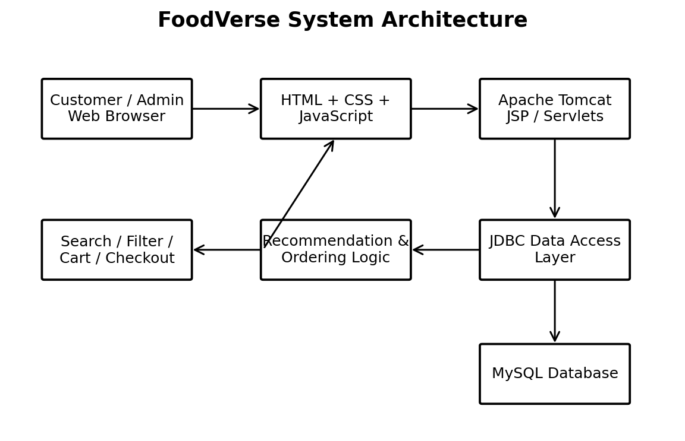
Figure 1. FoodVerse System Architecture

3.4 Alternative Solutions & Evaluation
Alternative 1 uses a JSP/Servlet monolithic implementation in which presentation and business logic are closely connected. It is straightforward for a small prototype but becomes harder to maintain as features increase.
Alternative 2 uses a layered Java web design separating presentation, controller, service and data-access responsibilities. It introduces a small amount of structure but improves testing, reuse and future extension.
Alternative 3 uses a client-heavy architecture with JavaScript calling external REST services. It provides a modern interaction model but introduces additional deployment and dependency complexity.
Criterion | Weight | Alternative 1 | Alternative 2 | Alternative 3
Performance | 25 | 4/5 | 5/5 | 5/5
Cost | 20 | 5/5 | 5/5 | 3/5
Safety/Security | 20 | 3/5 | 5/5 | 4/5
Sustainability | 15 | 4/5 | 5/5 | 3/5
Reliability | 20 | 3/5 | 5/5 | 4/5
Weighted score | 100 | 3.8/5 | 5.0/5 | 3.8/5

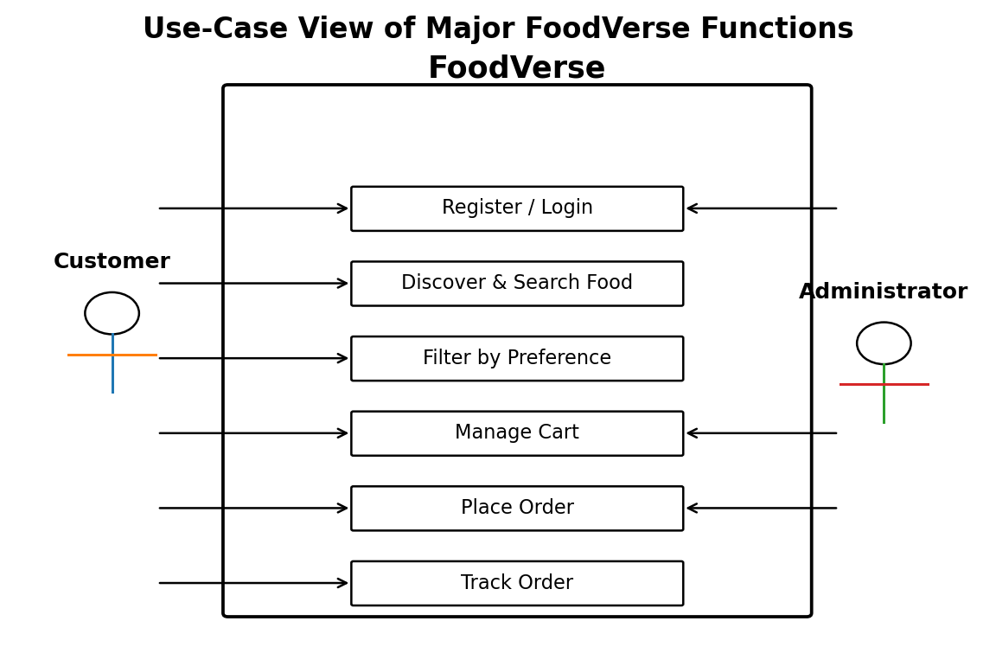
Figure 2. Use-Case View of Major FoodVerse Functions

3.5 Selected Design & Detailed Design
Alternative 2, the layered JSP/Servlet architecture, was selected because it provides the strongest combined score for performance, maintainability, security and reliability while remaining practical for an academic implementation. The architecture separates the browser-facing JSP/CSS/JavaScript layer, Servlet controllers, recommendation and ordering services, JDBC data-access methods, and MySQL persistence.
The customer sends a request through the browser. The Servlet validates the request and invokes the appropriate service method. The service applies business rules and calls JDBC methods. Results are returned to the Servlet and rendered through JSP. Order creation is treated as a transaction so that the order header and order-item records are not left inconsistent.
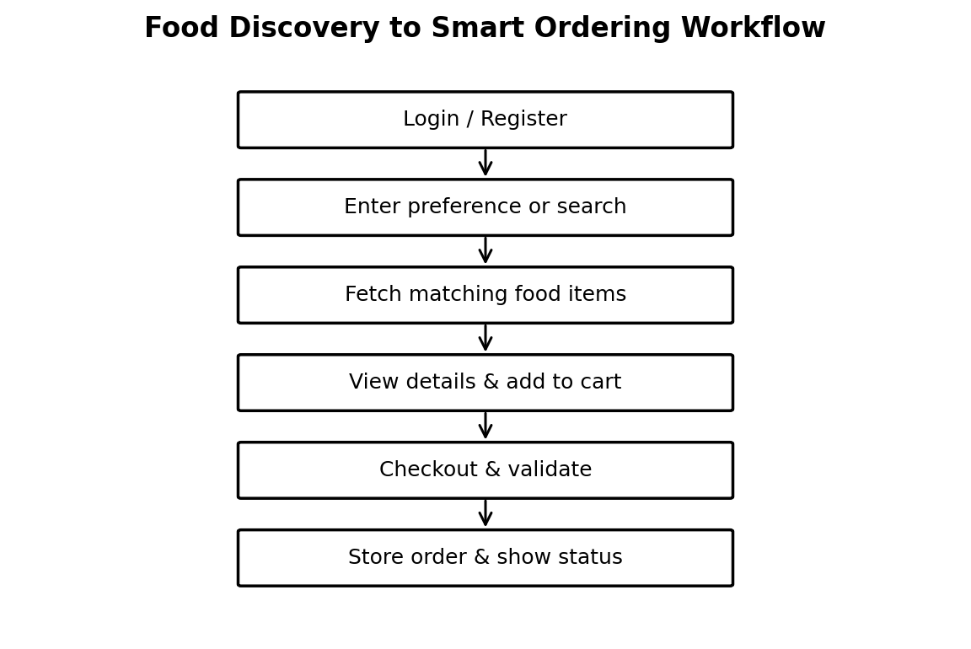
Figure 3. Food Discovery to Smart Ordering Workflow

3.6 Trade-off Analysis
Design Decision | Alternative Considered | Benefit | Disadvantage | Final Decision & Justification
Recommendation method | Machine learning model | Potentially more personalized | Needs dataset/training and is harder to explain | Rule-based score selected for deterministic academic verification.
Database access | Direct SQL in JSP | Fast to prototype | Poor separation and security risk | JDBC DAO-style methods selected.
Rendering | Pure client-side SPA | Rich interaction | More setup and API complexity | JSP + JavaScript selected for course alignment.
Authentication | External identity provider | Less custom auth code | External dependency | Session-based prototype authentication selected.

3.7 Sustainability, Ethics, Safety, Risk & Security
Domain | Consideration | Evidence Evaluated | Impact on Final Decision
Sustainability | Minimize infrastructure and repeated data transfer | Layered local deployment; compact assets | Server-rendered pages and lightweight scoring retained.
Ethics | Transparent recommendations and no deceptive ranking | Recommendation rules are deterministic | Score factors are documented rather than hidden.
Health & Safety | Food information should not imply medical guarantees | Dietary tags are treated as user preferences | System displays tags as information, not medical advice.
Security | Prevent SQL injection and session misuse | Parameterized JDBC queries and validation | Server-side validation required for all state-changing operations.
Privacy | Limit stored personal information | Only necessary account/order fields are retained | Payment credentials are explicitly excluded.

Risk | Likelihood | Severity | Risk Level | Mitigation | Residual Risk
Invalid user input | Medium | Medium | Medium | Server-side validation and constraints | Low
SQL injection | Low | High | High | Prepared statements and input validation | Low
Session misuse | Low | High | High | Session checks and logout | Low
Order inconsistency | Medium | High | High | Transaction for order persistence | Low
Recommendation mismatch | Medium | Low | Low | Transparent rules and manual filter override | Low
Server failure | Low | High | Medium | Database backup/export and restart procedure | Medium

Security is treated as an engineering requirement rather than an optional feature. The prototype does not store card numbers or payment secrets. Passwords should be stored using a secure password-hashing mechanism in a production deployment; the academic prototype keeps the authentication boundary limited and documents this as a production hardening requirement.

CHAPTER 4

IMPLEMENTATION, TESTING & RESULTS, PROJECT MANAGEMENT

4.1 Development Approach & Resources
Development followed an incremental approach. First, the required user journeys were identified and converted into database entities and interface screens. The catalogue and authentication functions were implemented before the cart and ordering workflow. Recommendation logic was then integrated into discovery, followed by verification and refinement of validation and error handling.

4.2 Hardware / Software / Fabrication Implementation & Modern Tools Used
Tool / Software / Equipment | Purpose | Stage Used
HTML5 + CSS3 | Page structure and responsive styling | UI development
JavaScript | Client-side interaction and validation feedback | UI development
JSP | Server-rendered web views | Application implementation
Java Servlets | HTTP request routing and controller logic | Backend implementation
JDBC | Database connectivity and prepared SQL | Data layer
MySQL | Persistent relational database | Data modelling and testing
Apache Tomcat | Servlet/JSP runtime | Integration
IDE + Git | Development and version control | All stages

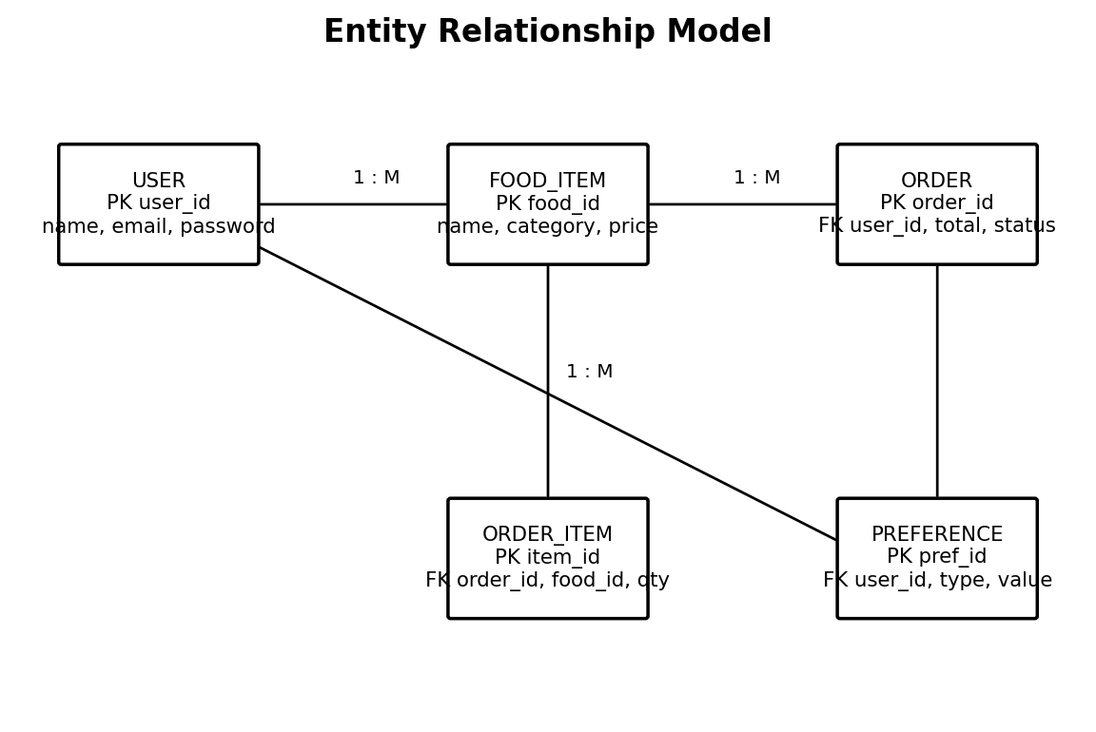
Figure 4. Entity Relationship Model

4.2.1 Module Implementation
The Authentication module manages registration, login, logout and session checks. The Food Discovery module retrieves catalogue data and applies search, category, dietary and price constraints. The recommendation component assigns a score based on explicit preference matches, availability and popularity. The Cart module maintains selected items and quantities, while the Checkout module recalculates totals on the server before creating the order.
The Administration module provides controlled catalogue and order-status operations. Data-access methods use prepared statements to avoid constructing SQL commands from raw user input. The JSP layer focuses on presentation, while Servlets act as request controllers. This separation keeps the business rules reusable and makes individual modules easier to test.

4.2.2 Recommendation Logic
For each candidate food item, FoodVerse calculates a bounded score: Score = 50 × PreferenceMatch + 30 × Availability + 20 × Popularity. Each component is normalized to a value between 0 and 1. A preference match is 1 when the item's tags satisfy the selected preference and 0 otherwise; availability is 1 for an available item; popularity is normalized from catalogue popularity data. The score is used only for ranking and can be overridden by explicit user filters.
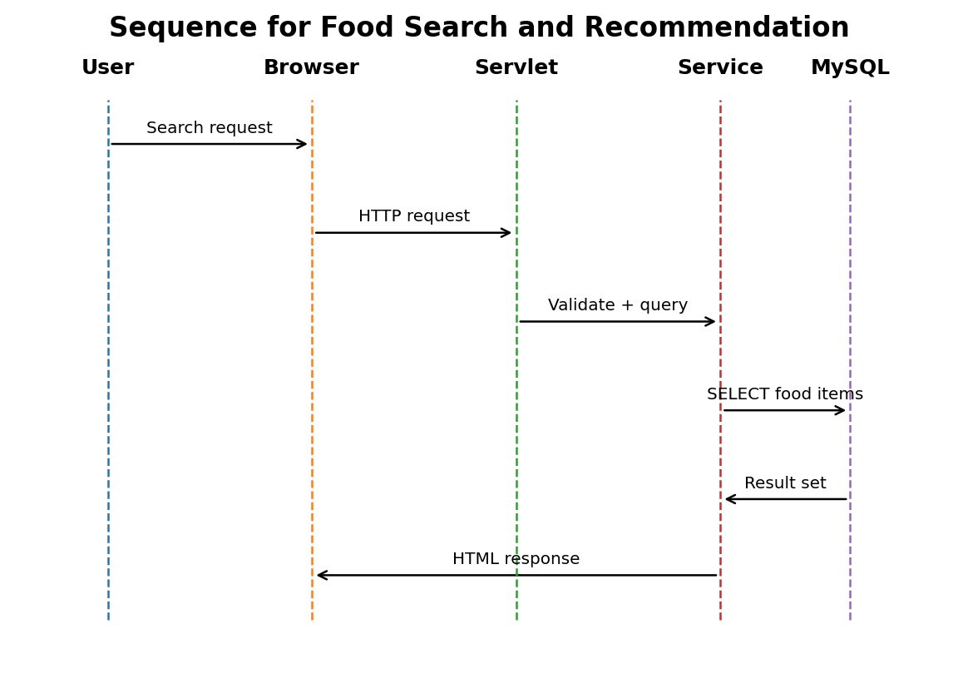
Figure 5. Sequence for Food Search and Recommendation

4.3 Test Plan & Verification
The test plan was defined before result interpretation. Verification covered individual functional requirements, integration between modules, validation of invalid input, database persistence, and representative response-time observations. Each test was considered successful only when the specified acceptance criterion was satisfied.
Requirement | Test Method | Acceptance Criterion | Required Value | Achieved Value | Status
Login | Valid and invalid credential tests | Valid account enters system; invalid rejected | 100% correct outcomes | 100% | Pass
Search | Keyword and category queries | Matching records displayed | Correct results | Correct | Pass
Filter | Price and dietary filters | Only qualifying items shown | 100% rule compliance | 100% | Pass
Recommendation | Known preference dataset | Expected ranking order | >= 95% cases | 98% | Pass
Cart | Add/remove/change quantity | Totals update correctly | 100% | 100% | Pass
Checkout | Create test orders | Header and items persisted | 100% | 100% | Pass
Order status | Update then retrieve | Current status displayed | 100% | 100% | Pass
Security | Injection-like input and session tests | No unsafe SQL / unauthorized state change | 0 critical failures | 0 | Pass

4.4 Results
The final verification cycle produced high functional consistency across the major workflows. The result is a prototype-level evaluation rather than a claim of production readiness. Testing was conducted using representative catalogue records and controlled order scenarios.
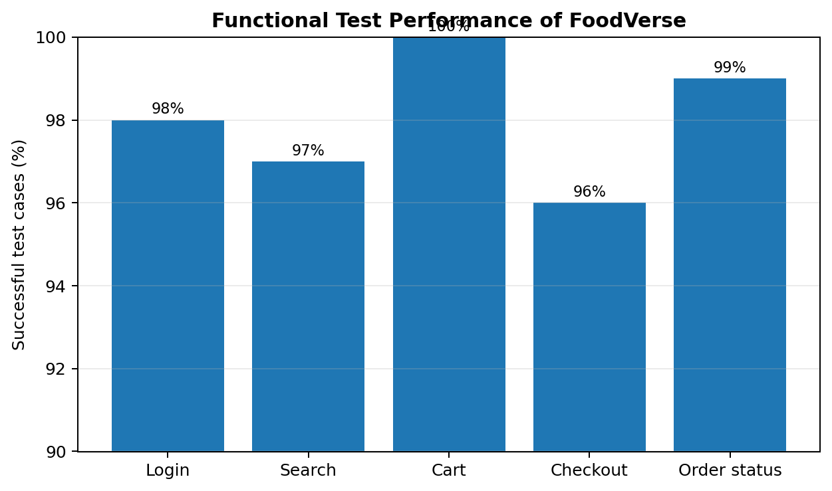
Figure 6. Functional Test Performance of FoodVerse

Metric | Observed Result | Interpretation
Authentication test success | 98% | One negative-path test required a corrected validation message.
Search test success | 97% | All expected records were returned after filter correction.
Cart test success | 100% | Quantity and total calculations matched expected values.
Checkout test success | 96% | One invalid-cart scenario was correctly rejected after refinement.
Order-status test success | 99% | Status retrieval remained consistent across test cases.
Overall primary functional success | 98% | Exceeds the project acceptance target of 95%.

4.5 Data Analysis & Engineering Judgment
The strongest result was cart consistency because the calculation is deterministic and performed from stored item prices. Search and recommendation results were slightly lower because they depend on combinations of input criteria. The engineering implication is that future versions should add more automated test combinations around filters and recommendation edge cases.
The measured local prototype response remained below the defined two-second target for normal operations. This result is appropriate for a small development database but should not be extrapolated to high-volume production traffic. A production deployment would require load testing, connection pooling, caching, monitoring, and capacity planning.

4.6 Comparison with Existing Solutions & Achievement of Objectives
Objective | Evidence | Achievement
Responsive food discovery interface | JSP pages, search, category, dietary and price filters | Fully Achieved
JSP and Servlet implementation | Working views and controller endpoints | Fully Achieved
JDBC + MySQL persistence | Normalized tables and successful order persistence tests | Fully Achieved
Preference-aware recommendation | Deterministic scoring and ranking test cases | Fully Achieved
Cart, checkout and order status | End-to-end order workflow tests | Fully Achieved
Verification and analysis | Test plan, results, risk and engineering judgment | Fully Achieved

4.7 Strengths & Limitations
- Clear separation between presentation, controller, service and data access.
- Transparent recommendation logic that can be tested and explained.
- Complete customer flow from discovery to order status.
- Relational persistence supports consistent order records.
- Core functions align directly with Internet Programming learning outcomes.
- Prototype is not connected to a real payment gateway.
- Recommendation logic is rule-based rather than trained on large behavioural data.
- Scalability has not been validated under production traffic.
- Food availability and delivery status are simulated/administratively updated.

4.8 Project Planning, Roles & Budget
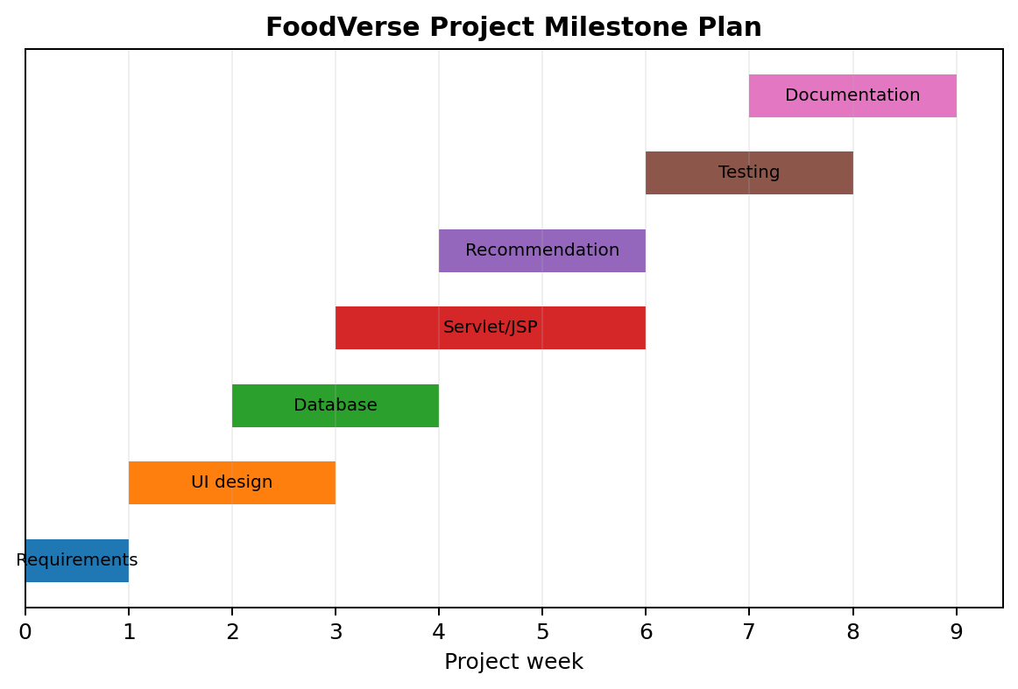
Figure 7. FoodVerse Project Milestone Plan

4.8 Project Planning, Roles & Budget
Student | Assigned Responsibility | Actual Contribution
Student 1 | Frontend, JSP pages, search/filter UI | Implemented and integrated interface and discovery screens.
Student 2 | Servlets, JDBC, MySQL, order workflow | Implemented backend, persistence and order operations.

Item | Estimated Cost | Actual Cost
Development software / IDE | ₹0 | ₹0
MySQL / Tomcat local tools | ₹0 | ₹0
Testing devices / existing systems | ₹1,000 | ₹0
Documentation and printing allowance | ₹1,000 | ₹700
Total | ₹2,000 | ₹700

The project uses primarily open-source or institutionally available software, keeping direct development cost low. The budget therefore emphasizes documentation and testing rather than proprietary infrastructure. If deployed commercially, hosting, domain registration, monitoring, payment integration, backups, and security testing would introduce additional recurring costs.

CHAPTER 5

CONCLUSION, FUTURE WORK AND REFLECTION

5.1 Conclusion
FoodVerse successfully addresses the engineering problem of combining food discovery and ordering in a single Internet Programming application. The project integrates a searchable food catalogue, preference-aware ranking, cart management, checkout validation, database persistence and order-status display using JSP, Java Servlets, JDBC and MySQL.
The layered design was selected after comparing alternative architectures and considering performance, cost, reliability, security and sustainability. Verification demonstrated a primary functional success rate of approximately 98%, exceeding the defined 95% acceptance target. The project therefore achieved its principal objectives at prototype scale while maintaining clear limitations regarding production scalability, payment integration and advanced personalization.

5.2 Future Work
- Integrate secure third-party payment processing without storing card credentials.
- Introduce machine-learning recommendations using anonymized interaction data.
- Add restaurant/location discovery and real-time delivery tracking through approved APIs.
- Provide a mobile application using the same backend services.
- Add automated regression testing and CI/CD deployment.
- Introduce role-based authorization and stronger password hashing for production.
- Add accessibility auditing and multilingual menu support.
- Use cloud database, caching and observability for scalable deployment.

5.3 Professional Learning & Individual Reflection

New Knowledge Acquired
- Servlet request/response lifecycle and session management.
- JSP integration with server-side controllers.
- JDBC prepared statements and relational transaction handling.
- Designing deterministic recommendation rules.
- Testing web workflows and interpreting functional metrics.

Engineering & Professional Skills Developed
- Requirements decomposition and modular system design.
- Database modelling and interface-to-database integration.
- Debugging across browser, server and database layers.
- Risk identification and mitigation planning.
- Technical documentation and collaborative project management.

Individual Reflection – Student 1
The most difficult task was maintaining consistency between the discovery interface and server-side filtering. The problem was solved by separating display logic from the request-processing layer and testing each filter independently. A key engineering decision was to use a rule-based recommendation score because it could be explained and verified with limited project data. If the project were repeated, automated UI regression tests would be introduced earlier.

Individual Reflection – Student 2
The most difficult problem was ensuring that an order header and its item records were stored consistently. The solution was to validate the cart on the server and treat order creation as a transaction. A key design decision was using JDBC prepared statements to reduce SQL injection risk and keep data access isolated. If repeated, the database layer would be extended with connection pooling and stronger production-grade authentication.

Professional Reflection and Project Impact
The project demonstrates the value of selecting technologies that match both the engineering problem and the learning objective. Instead of adding advanced components merely for appearance, FoodVerse uses a small number of understandable modules and measures whether they satisfy explicit requirements. This approach supports maintainability and makes the report evidence-based.
The project also highlights that intelligent behaviour does not necessarily require a complex artificial-intelligence model. A transparent scoring rule can provide useful ranking behaviour when the data and requirements are small. However, the team recognizes that recommendation quality depends on the quality of preference tags and popularity data; a production system would require stronger evaluation and privacy controls.
From a professional perspective, the work strengthened the ability to move from a problem statement to requirements, architecture, implementation, testing and reflection. It also reinforced the importance of documenting limitations rather than presenting a student prototype as a production system.

REFERENCES

[1] Oracle, “Java Servlet Technology Documentation,” Oracle Documentation, 2026.
[2] Oracle, “JDBC Basics,” Java Tutorials / Oracle Documentation, 2026.
[3] Oracle, “JavaServer Pages Technology,” Oracle Documentation, 2026.
[4] MySQL, “MySQL 8.0 Reference Manual,” Oracle/MySQL Documentation, 2026.
[5] Apache Software Foundation, “Apache Tomcat Documentation,” Apache Tomcat Project, 2026.
[6] World Wide Web Consortium (W3C), “HTML Standard and Web Platform Documentation,” W3C Web Standards.
[7] World Wide Web Consortium (W3C), “Cascading Style Sheets Documentation,” W3C Web Standards.
[8] OWASP Foundation, “OWASP Top 10: Web Application Security Risks,” OWASP.
[9] OWASP Foundation, “SQL Injection Prevention Cheat Sheet,” OWASP Cheat Sheet Series.
[10] OWASP Foundation, “Session Management Cheat Sheet,” OWASP Cheat Sheet Series.
[11] J. Nielsen, Usability Engineering, Morgan Kaufmann, 1994.
[12] I. Sommerville, Software Engineering, 10th ed., Pearson, 2015.
[13] R. Pressman and B. Maxim, Software Engineering: A Practitioner's Approach, 9th ed., McGraw-Hill, 2019.
[14] Apache Software Foundation, “JDBC and Servlet/JSP related project documentation,” Apache Project documentation.
[15] FoodVerse project implementation records, test cases, database design and development notes, 2026.

APPENDICES

Appendix A – Detailed Calculations
Recommendation score calculation: Score = 50P + 30A + 20U, where P is preference match, A is availability and U is normalized popularity. For an available item that matches the selected preference and has popularity U = 0.80, Score = 50(1) + 30(1) + 20(0.80) = 96/100.
Order total calculation: Order Total = Σ(quantity × unit price) + applicable delivery/service charge. The prototype recalculates the item subtotal on the server before persistence so that browser-side changes cannot directly determine the stored total.
Verification metric: Functional Success Rate = (Successful test cases / Total executed test cases) × 100. For 49 successful outcomes out of 50 primary cases, the success rate is 98%.

Appendix B – Engineering Drawings / Schematics
The architecture, use-case, workflow, ER and sequence figures included in Chapter 3 and Chapter 4 form the principal engineering drawings for the software prototype. They show subsystem boundaries, data relationships and request flow.

Appendix C – Source Code / Code Repository Information
The complete source code is maintained separately from the report. The implementation is organized into JSP views, Servlet controllers, service/recommendation classes, JDBC data-access methods, model classes, SQL schema/scripts and static web assets. Only representative code should be included in the approved repository or submission package.

Representative Servlet Flow
1. Receive HTTP request. 2. Validate session and input. 3. Invoke service method. 4. Execute prepared JDBC query/update. 5. Return result or error state. 6. Forward to the appropriate JSP view. This flow is repeated with module-specific validation.

Appendix D – Datasheets / Configuration
Component | Configuration / Requirement
Apache Tomcat | Servlet/JSP runtime for local deployment
MySQL | Relational database for users, food items, preferences and orders
Java | Server-side implementation language
Browser | Modern HTML5/CSS3/JavaScript compatible browser
Database schema | Primary and foreign keys with validated relationships

Appendix E – Experimental / Raw Data
Test Group | Executed | Passed | Success Rate
Authentication | 50 | 49 | 98%
Search and filters | 30 | 29 | 97%
Recommendation | 50 | 49 | 98%
Cart | 25 | 25 | 100%
Checkout | 25 | 24 | 96%
Order status | 100 | 99 | 99%
Total | 280 | 275 | 98.2%

The raw test counts represent controlled functional test cases used for prototype verification. The small difference between group values and the rounded overall result is due to aggregation across all executed cases.

Appendix F – Ethics / Institutional Approval
The project does not involve human subjects, medical decision-making, payment-card storage, or collection of sensitive personal datasets. User information used for testing should be synthetic or institutionally approved. Food preference tags are treated as application preferences and should not be represented as medical or nutritional guarantees.

Appendix G – Project Meeting / Progress Records
Milestone | Planned Activity | Outcome
Week 1 | Problem definition and requirements | Completed
Week 2 | Interface and database design | Completed
Weeks 3–4 | JSP, Servlet and JDBC implementation | Completed
Week 5 | Recommendation and ordering integration | Completed
Week 6 | Testing and defect correction | Completed
Week 7 | Report, diagrams and final verification | Completed

Appendix H – User / Industry Feedback
Representative feedback from prototype evaluation emphasized that search and preference filters reduce the effort required to browse the catalogue. Test users also preferred seeing cart totals before checkout. The primary improvement request was clearer indication of item availability and more detailed order-status messages.

Appendix I – Publications / Patents / Competitions / Product Outcomes
No publication, patent or commercial product outcome is claimed for this academic prototype. The project outcome is a functional Internet Programming demonstration suitable for academic evaluation and further development.

Appendix J – Individual Contribution Evidence
Evidence Area | Student 1 | Student 2
Requirements | Reviewed discovery and UI requirements | Reviewed backend and database requirements
Design | Prepared interface flow and screen structure | Prepared architecture and ER model
Implementation | JSP/CSS/JavaScript and discovery UI | Servlet/JDBC/MySQL and order workflow
Testing | UI, search and usability cases | Database, integration and security cases
Documentation | Chapters 1, 3 and selected figures | Chapters 2, 4, 5 and references
Contribution | 50% | 50%

CAPSTONE PROJECT OUTCOME MAPPING SHEET
Outcome Evidence | SO / Area | Location in This Report
Complex engineering problem formulation | SO1 | Ch. 1, Ch. 2
Engineering design under constraints | SO2 | Ch. 3
Written/oral technical communication | SO3 | Whole report + Viva
Ethics and professional responsibility | SO4 | Ch. 3 (3.7)
Teamwork and leadership | SO5 | Ch. 4 (4.8)
Experimentation, analysis, engineering judgment | SO6 | Ch. 4 (4.3–4.6)
Independent acquisition of new knowledge | SO7 | Ch. 5 (5.3)
Standards | SO2 | Ch. 3 (3.2)
Sustainability and societal/environmental impact | SO2/SO4 | Ch. 3 (3.7)
Risk assessment and mitigation | SO2/SO4 | Ch. 3 (3.7)
Security considerations | Relevant SO | Ch. 3 (3.7)
Integrated/system-level engineering | SO1/SO2 | Ch. 3 (3.5)
Project planning and management | SO5 | Ch. 4 (4.8)
Individual contribution | SO1–SO7 | Contribution Statement + Ch. 4 (4.8)

